**METHODOLOGY**

1. Go to **AWS Console** and login in with your credentials.

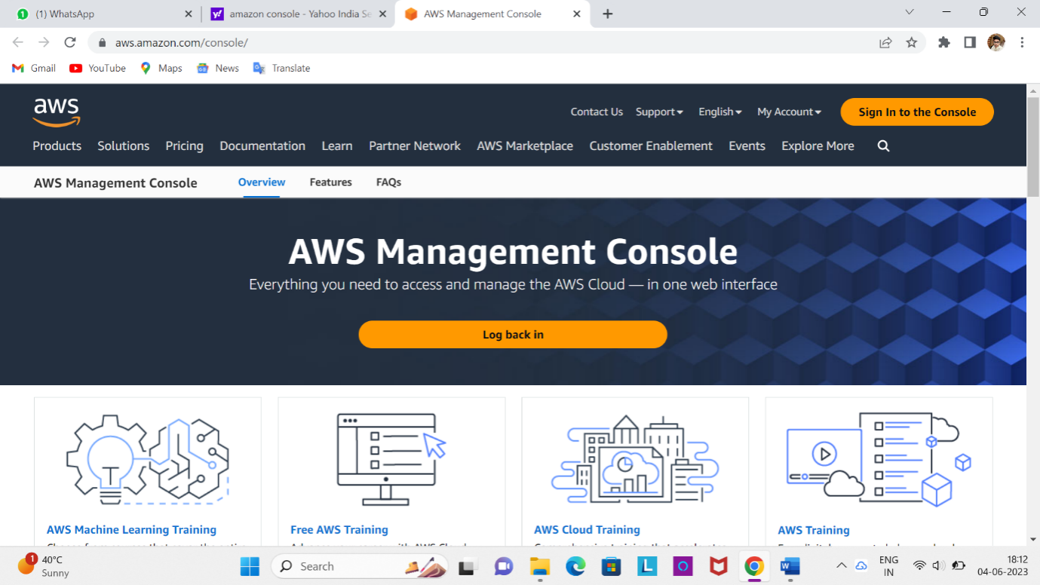

1. Now go to EC2 dashboard and open instances and go for launch instance.
2. Give the name to the instance like “21KN1A1208” and select the “Amazon Linux” operating system.
3. And launch the instances and after the instance is opened like this

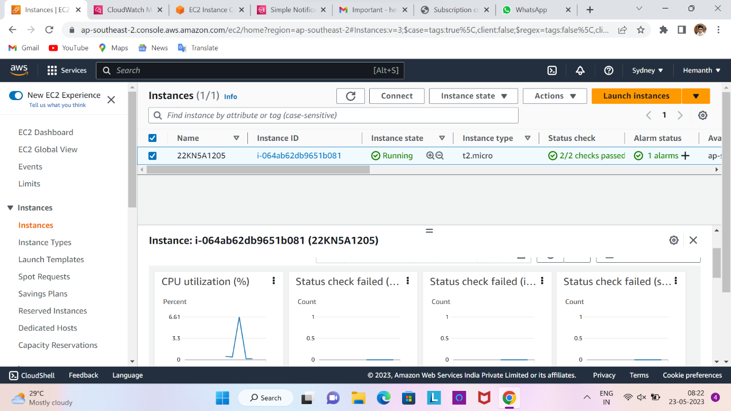

1. Go to the Cloud Watch tool and create the alarm like this and gives the threshold level to the CPU Utilization.

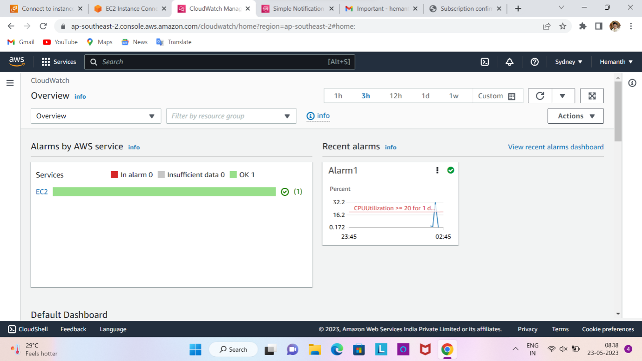

1. And create the ‘SNS(Simple Notification Service)’ topic like this

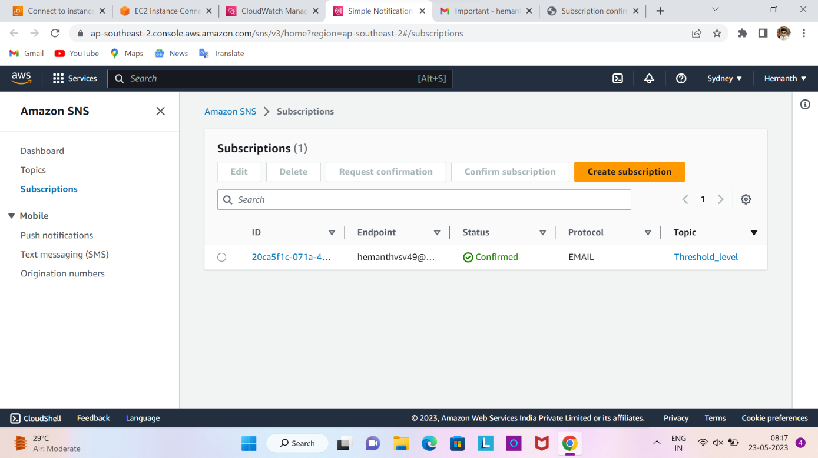

1. After creating the topic in SNS work on the instance after that the CPU Utilization reaches the threshold level.

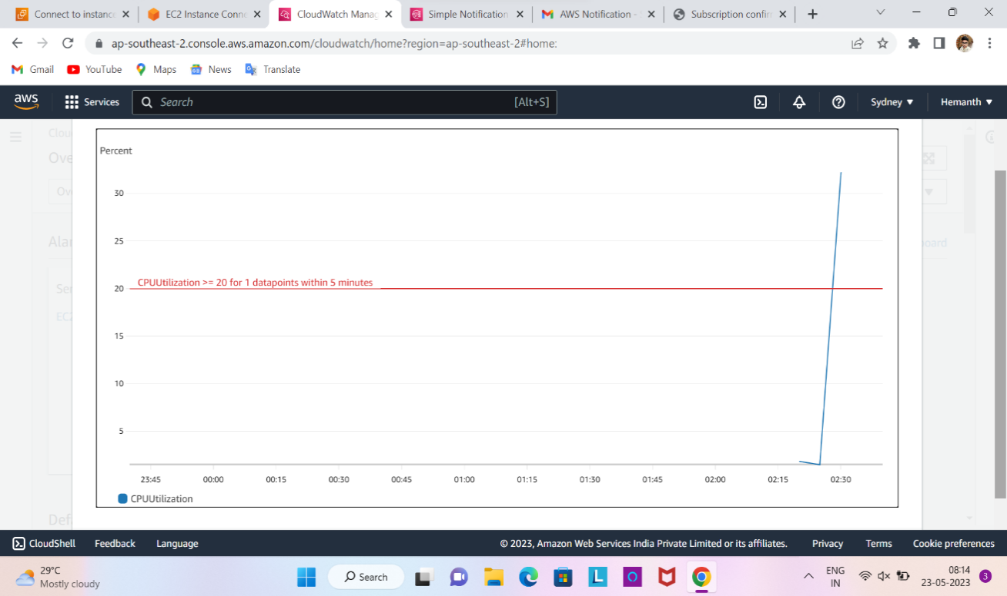

1. CPU Utilization reaches the maximum level this is in shown in the above figure.

After this it gives the notification to our given email.

**RESULT**

**Step1:**The Alarm will shows the threshold level in the red color like this.

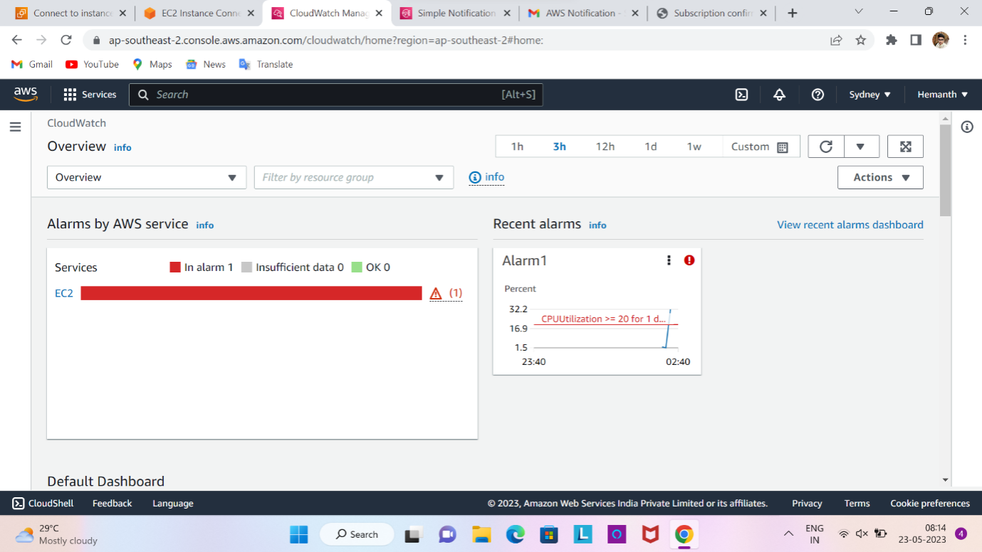

**Step2:**The Notification sends to our email like this format.

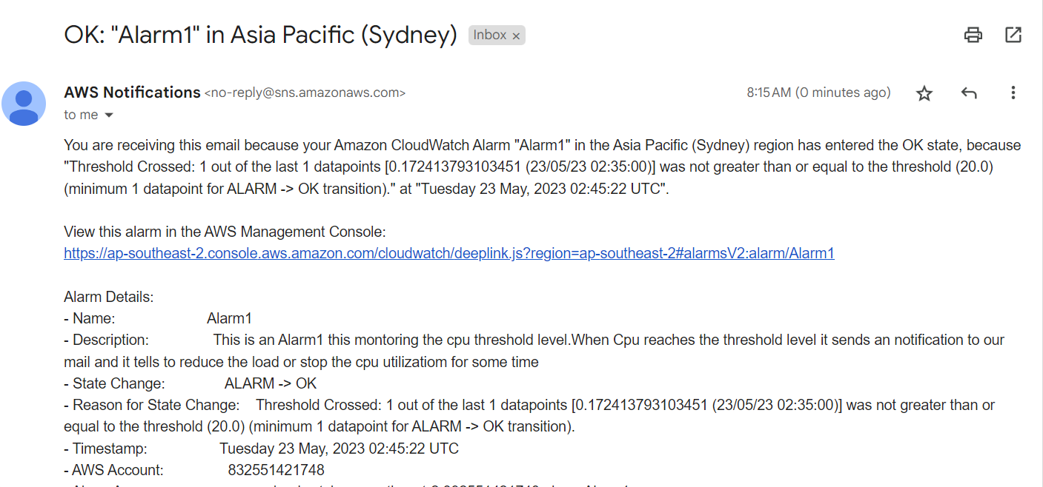

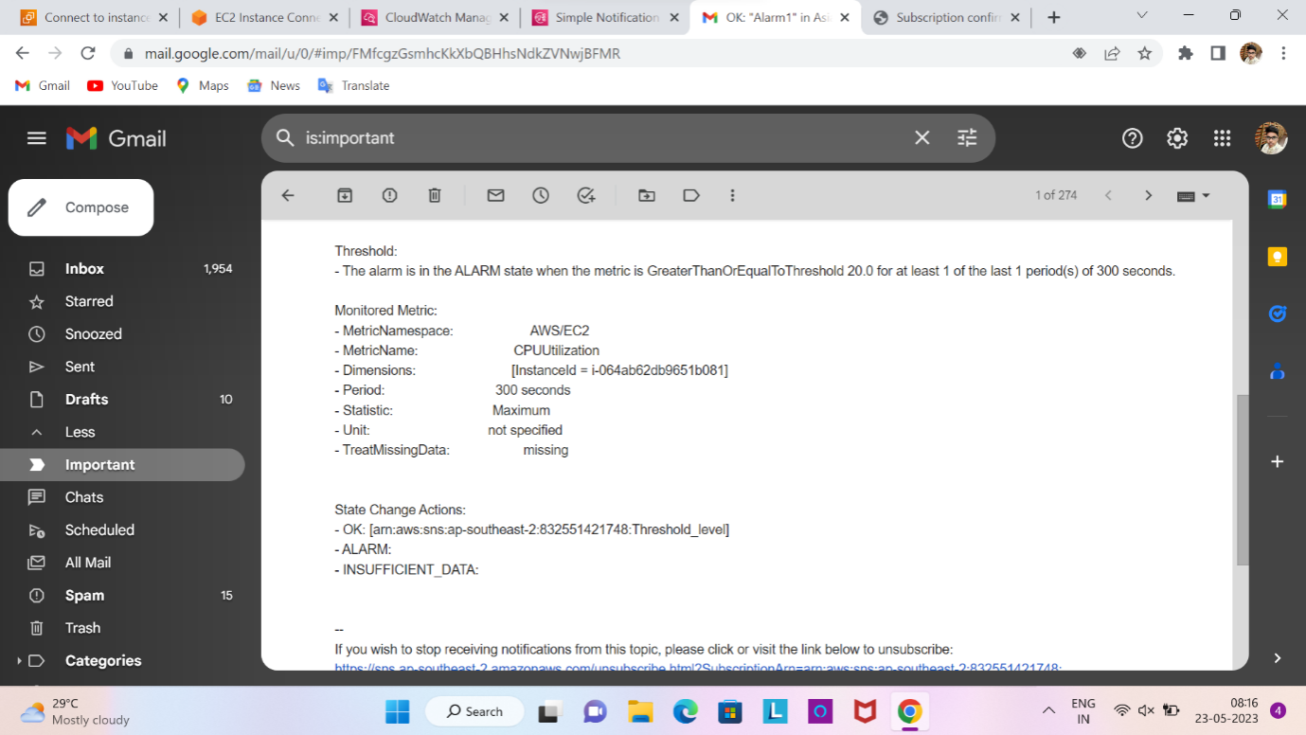

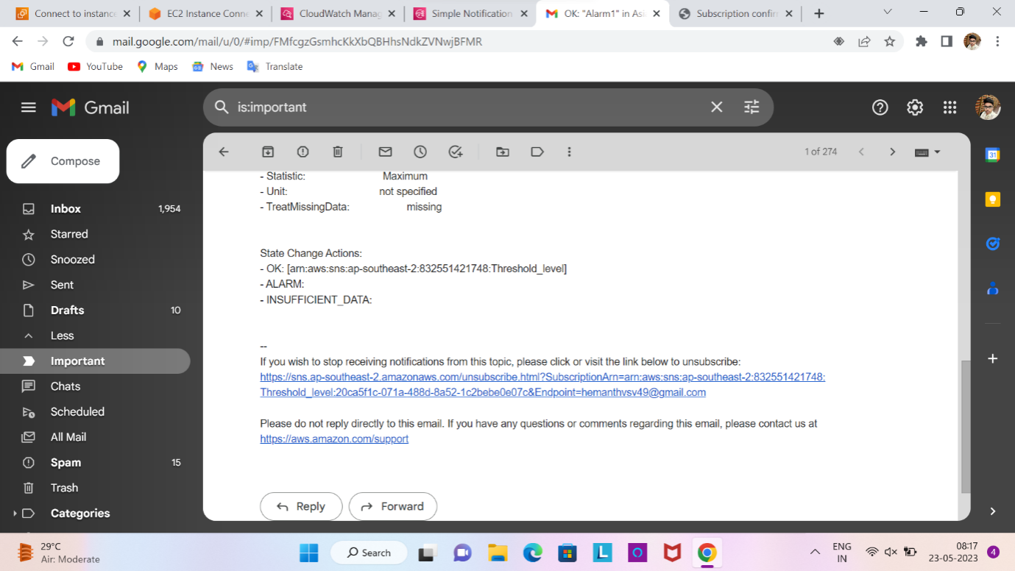

**CONCLUSION**

* In conclusion, by creating an EC2 instance and utilizing the CloudWatch tool to monitor its CPU utilization, you can implement an effective system for detecting and responding to high CPU utilization levels. This setup allows you to automatically send an email notification whenever the CPU utilization exceeds a specified threshold.
* This approach offers several benefits. Firstly, it enables proactive monitoring of your EC2 instance, ensuring that you can promptly address any performance issues that may arise. By setting a threshold for CPU utilization, you can define the level at which you consider the usage to be high and in need of attention.
* CloudWatch provides robust monitoring capabilities, allowing you to collect and analyze metrics from various AWS resources, including EC2 instances. By configuring CloudWatch to track CPU utilization, you gain valuable insights into the health and performance of your instance.
* When the CPU utilization exceeds the specified threshold, CloudWatch can trigger an action to send an email notification. This action ensures that you receive immediate alerts and can take appropriate measures to investigate and resolve any performance issues.
* Overall, this setup provides a proactive and automated approach to monitoring and managing CPU utilization in your EC2 instances. By leveraging the power of CloudWatch and email notifications, you can effectively maintain the performance and stability of your infrastructure.

**REFERENCES**

References:

* **Amazon CloudWatch console** – <https://console.aws.amazon.com/cloudwatch/>
* **AWS CLI** – For more information, see [Getting Set Up with the AWS Command Line Interface](https://docs.aws.amazon.com/cli/latest/userguide/cli-chap-getting-set-up.html) in the AWS Command Line Interface User Guide.
* **CloudWatch API** – For more information, see the [Amazon CloudWatch API Reference](http://docs.aws.amazon.com/AmazonCloudWatch/latest/APIReference/Welcome.html).
* **AWS SDKs** – For more information, see [Tools for Amazon Web Services](http://aws.amazon.com/tools).